Wk 13-14: Proj Dev: Handoff

# Part 1: Documentation Up to date

Determine the status of the feature(s) that you have worked on, update the information, documentation, and any other items.

## Is the requirements document up today?

Yes.

## Is the design document up to date?

Yes.

## Is the test plan up to date?

Yes.

## Is the software development guide up to date?

Yes.

## Is the installation guide up to date?

Yes.

## Is the user guide up to date?

Yes.

# Part 2: Check-in everything

## Make sure you have merged, checked in, and upload all your changes.

Done.

## Provide a screen shot of your GitHub Desktop to make sure you have uploaded everything.

### API

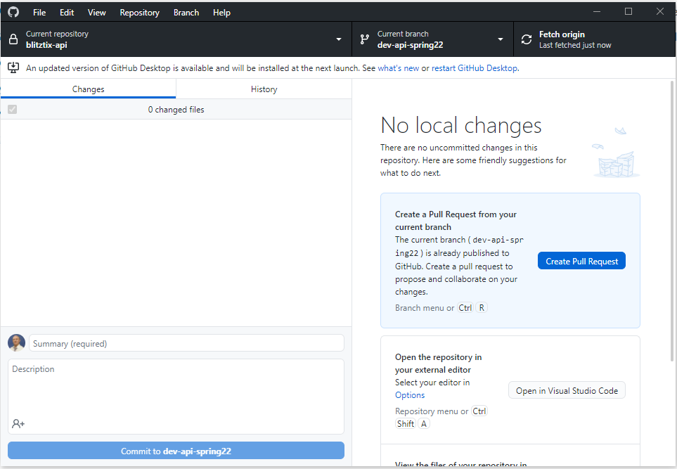

### Web

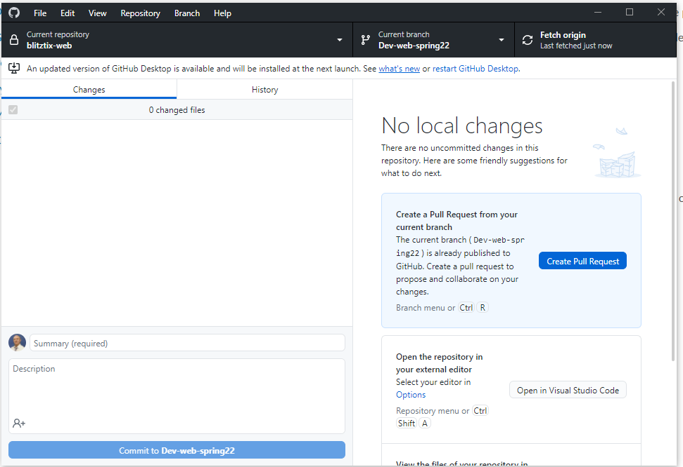

# Part 3: Personal Portfolio

## Is your personal GitHub account checked in?

Yes.